Wine Quality Workshop

Hands-On Workshop: Predicting Wine Quality  
Domino Data Lab

#### In this workshop, you will work through an end-to-end workflow broken into various labs.

* Read data from a live source.
* Prepare your data in an IDE of your choice, with an option to leverage distributed computing clusters.
* Train several models in various frameworks.
* Compare model performance across different frameworks and select the best-performing model.
* Deploy the model to a containerized endpoint and web-app frontend for consumption.
* Leverage collaboration and documentation capabilities throughout to make all work reproducible and shareable!

# Pre-setup

GitHub Configuration

We must add the GitHub PAT before continuing with the workshop. You can create a PAT using the following link. Using one from your personal GitHub account is Ok.

Create PAT: <https://github.com/settings/tokens>

Assuming you are logged in to the Domino platform, please click on **Account -> Account settings.**

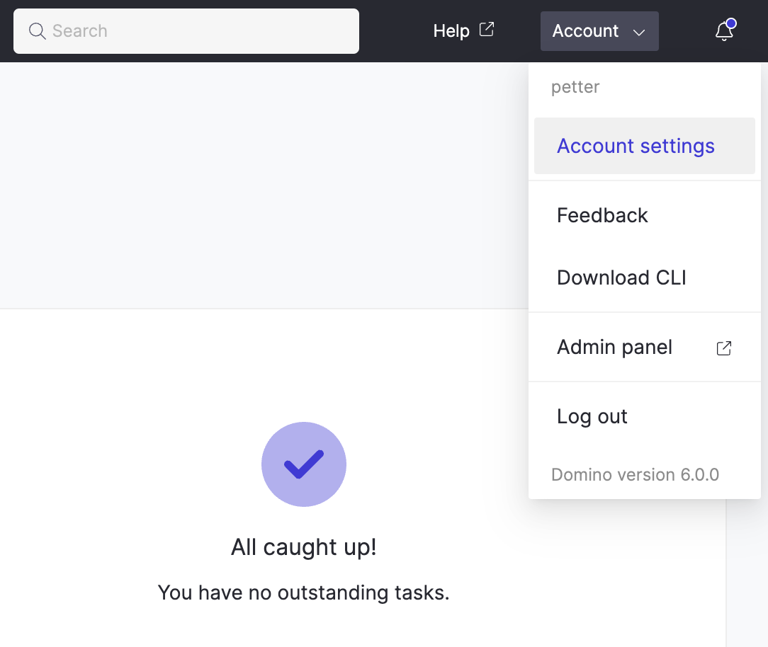

Next, you will click **Git Credentials -> Add Credentials.**

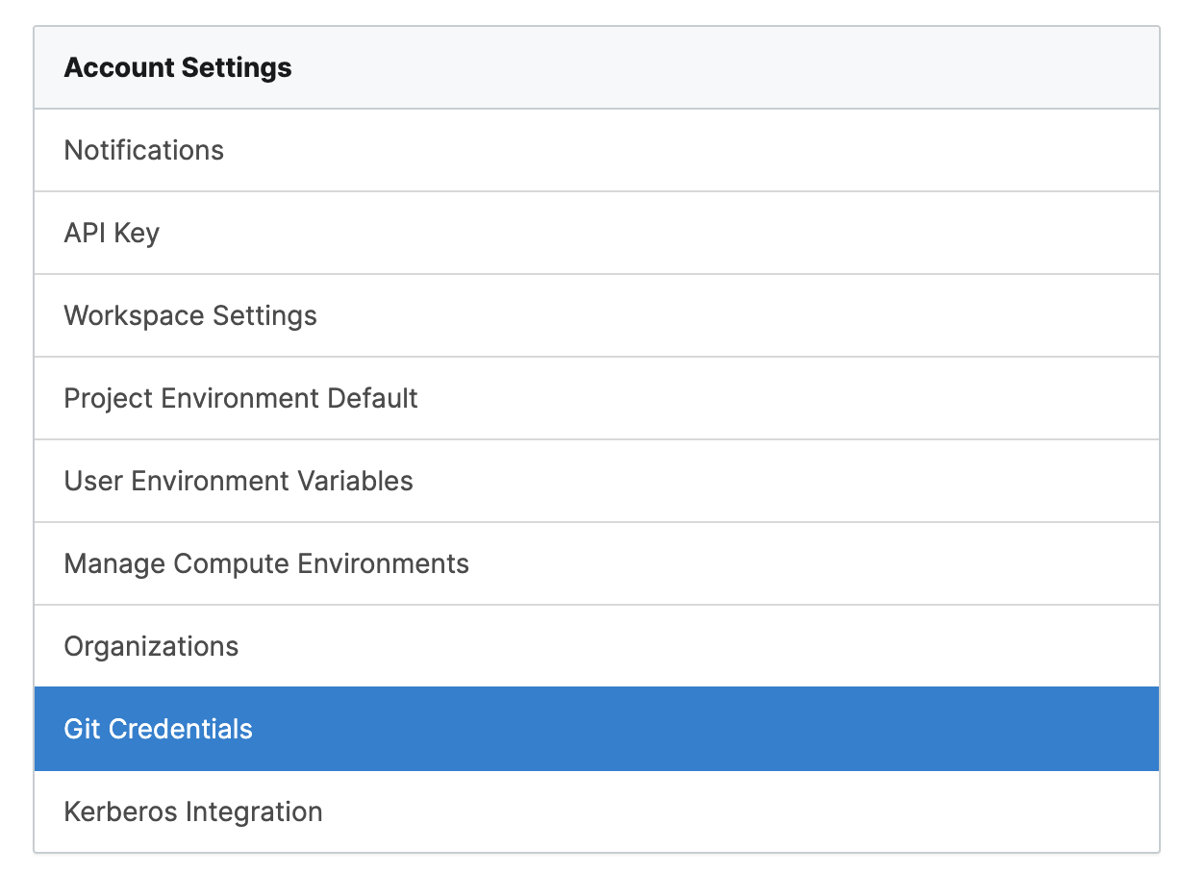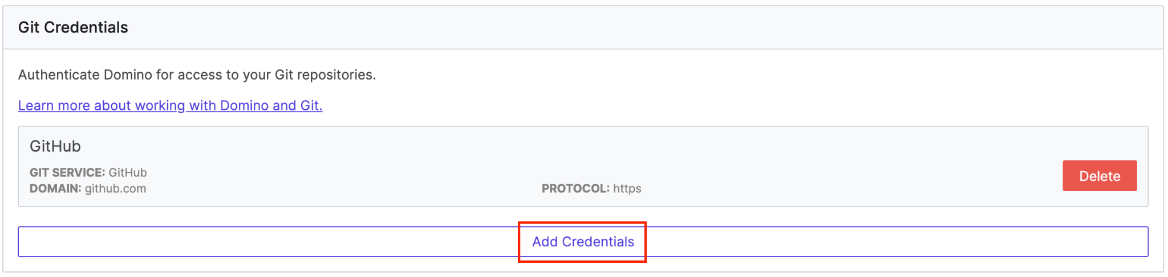

You will fill in your **Nickname, Git Service Provider, Access Type, and Personal Access Token,** and click Save.

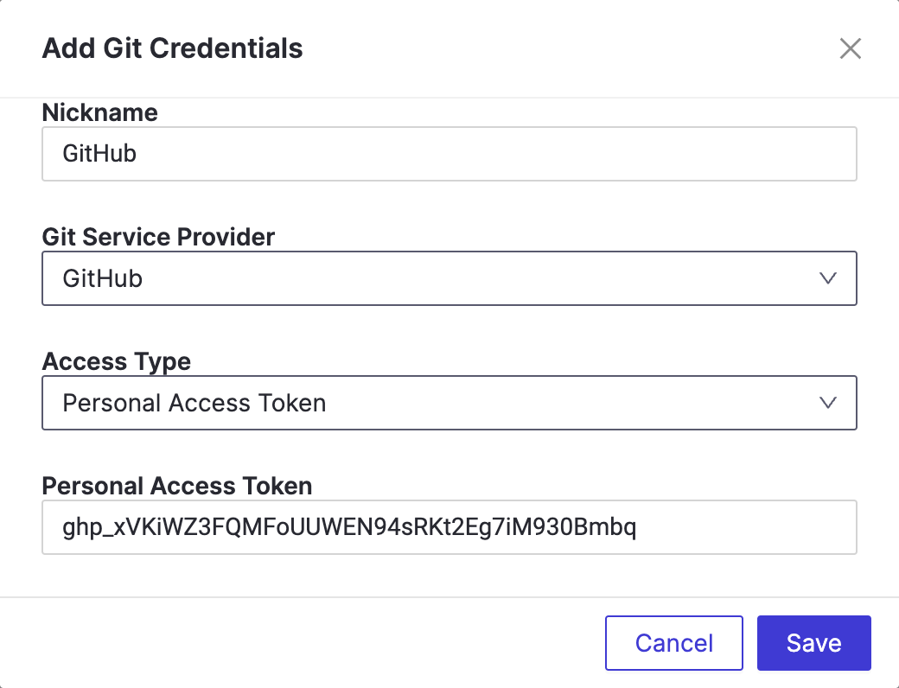

We are now finished with the pre-setup configuration and can continue with the workshop.